ANNEXURE -Ill (For Form-6)

# DECLARATION*

(For an elector of 21+ age group seeking fresh registration for the first time)

**Sunita**

**Ashishkumar Vishwakarma**

Son/DaughterWife ofRio **140/G New Ganesh Nagar T.H kataria Marg Matunga Mumbai** declare as under: -

**Mahim**

I have applied for registration in the electoral roll ofconstituency, as my name does not figure in electoral roll anywhere in India.

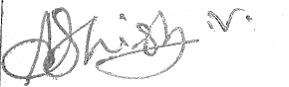2. I have not been issued any EPIC at any time in the past in any constituency.

Signature of the Applicant Batelace:

Place **Mumbai**

Date: 10/11/2019

*(Making false declaration in matters related to preparation/revision of electoral roll is an offence punishable under Section 31 of the Representation of the People Act, 1951, and also under the provisions of the

Indian Penal Code)